December
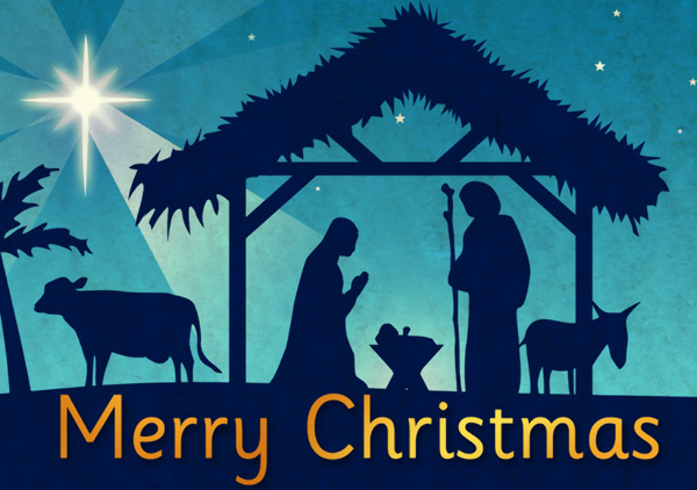
2022
Sunday | Monday | Tuesday | Wednesday | Thursday | Friday | Saturday
 |  |  |  | 1 | 2 | 3
4 | 5 | 6 | 7 | 8 | 9 | 10
Advent Service  10AM |  |  | Happy Birthday  Renee Stine!!! |  | Happy Birthday Robbie Longoria!!!  Cookie Drop
11 | 12 | 13 | 14 | 15 | 16  Church Outing  St. Pauls in Toledo.  Meet @ the church at 3:30. Cookie Drop | 17
 |  | Knitting Ministry  1pm |  | Community Meal  5pm-6pm
18  Advent Service  10 AM | 19 | 20 | 21 | 22 | 23 | 24
Lessons and Carols 10am  Happy Birthday  Tyler Rodrigue-Hejhal!!! |  |  | Vestry 4:00 |  | Happy Birthday Pastor Bob Butcher!!!  Cookie Drop | Concert and Candle Light Service 6pm  Happy Birthday  John Bolte!!!
25 | 26 | 27 | 28 | 29 | 30 | 31
Merry Christmas!! No Service | 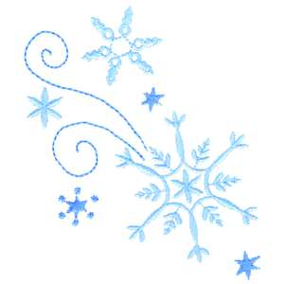 | Knitting Ministry  1pm |  |  | Cookie Drop

Advent Service
10 AM

